A large bird with an amazing, colourful tail. | PEACOCK | 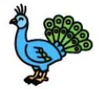
This animal is long. It has no legs. | SNAKE | 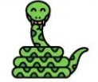
A sea creature with a soft and almost transparent body. It can sting you. | JELLYFISH | 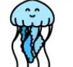
A large, green insect that holds its front legs in a way that makes it look as if it is praying | PRAYING MANTIS | 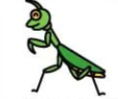
A sea creature with 8 tentacles. | OCTOPUS | 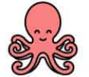
A large, flat fish with a long tail and poisonous points on it. | STINGRAY | 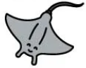
This is a very big animal; it has a trunk. | ELEPHANT | 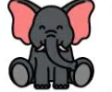
It’s the biggest animal alive! | WHALE | 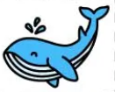
This animal gives us milk. | COW | 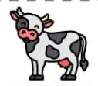
A small rodent with rounded ears, no tail. Often kept as a pet by children. | GUINEA PIG | 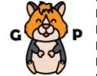
A reptile which has a thick shell covering its body. It is very slow. | TURTLE | 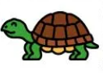
A mammal that moves very slow and lives in trees. | SLOTH | 